AU set up table:

|  |  |  |  |
| --- | --- | --- | --- |
| AU set up  instructions | AU mode | AU left | AU right |
| LDAC | Add without carry | zero | Reg O |
| LDBC | Add without carry | zero | Reg O |
| LDAM | Add without carry | zero | Reg O |
| LDBM | Add without carry | zero | Reg O |
| STAM | Add without carry | zero | Reg O |
| ADD | Add without carry | Reg A | Reg B |
| SUB | Subtract | Reg A | Reg B |
| LDAI | Add without carry | Reg A | Reg O |
| Fetch | Add without carry | Reg PC | zero |
| Increment PC | Add with carry | Reg PC | zero |

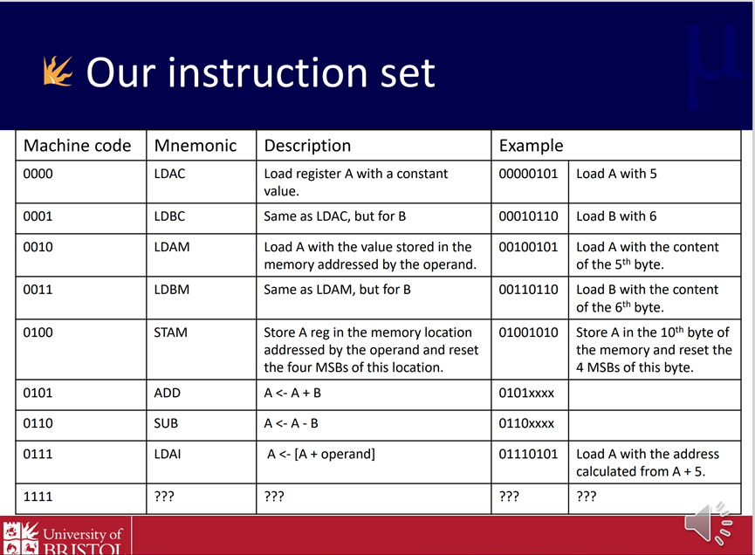

diff.hex: #95 minus #81

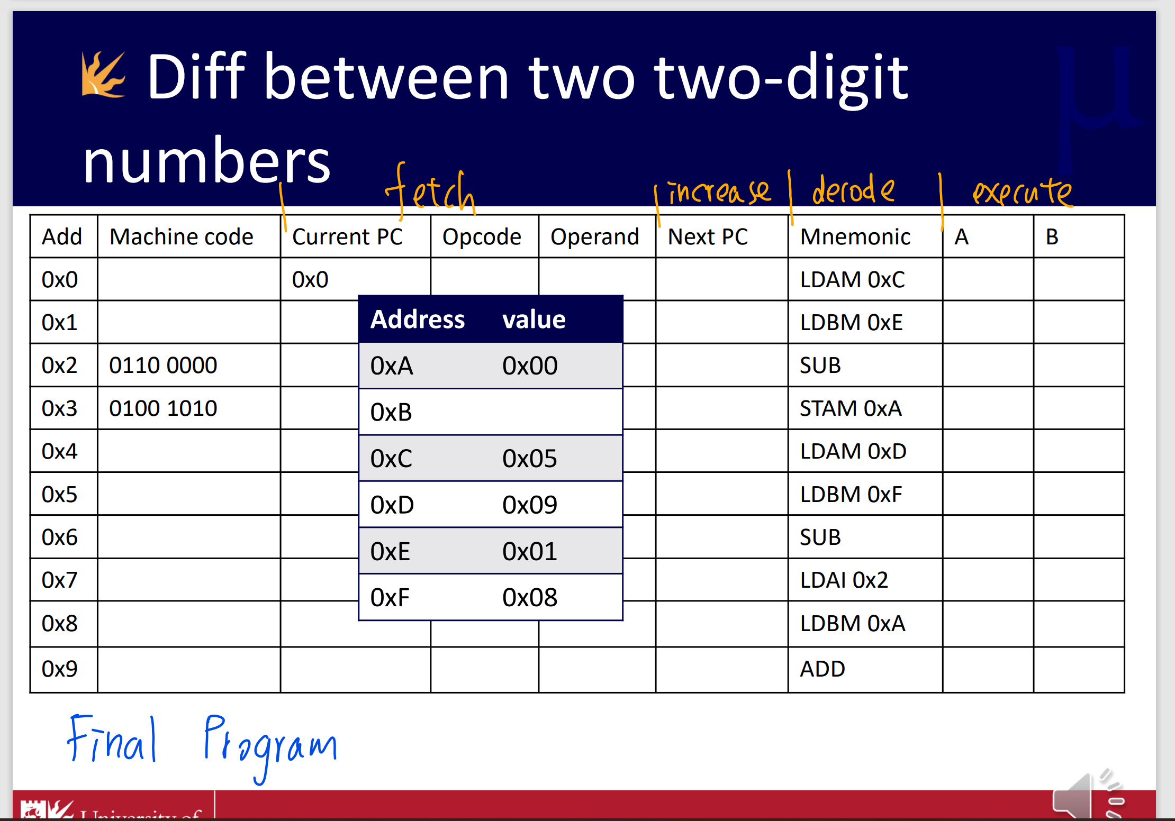



The answer 14 (1110) will show up in reg A at instruction 0x9 (PC = 1010).

Simple CPU lab -2 extra: For loop(with BR(1000) and BRZ(1001))